## SMART RESTROOM

## Phase-2

### Innovation:

Once you have all of the necessary components, you can start implementing the smart restroom system. The following steps are involved:

1.Install the required components in the restroom and monitor the cleanliness of the restroom.

2.To ensure that the components are fitted/connected in the restroom all the sensors working properly.

3.To monitor and the maintain through embedded system and Iot devices and to maintain the quality of the restroom

**Circuit Components:**

1. Occupancy Sensor for Lighting Control

**Components:**

Passive Infrared (PIR) Sensor: 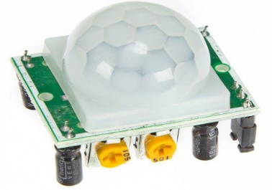

Relay Module:

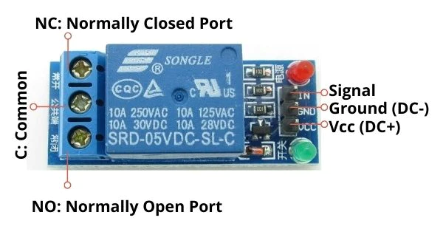

LED Lighting :

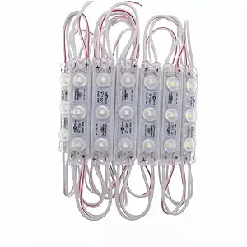

**Circuit Description:**

The PIR sensor detects motion in the restroom.

When motion is detected, the sensor sends a signal to the microcontroller.

The microcontroller activates the relay module, which controls the LED lighting.

**2. Automated Faucet Control**

**Components:**

IR Sensor (for proximity detection):

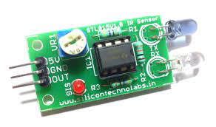

Solenoid Valve:

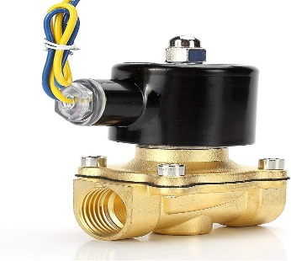

Microcontroller:

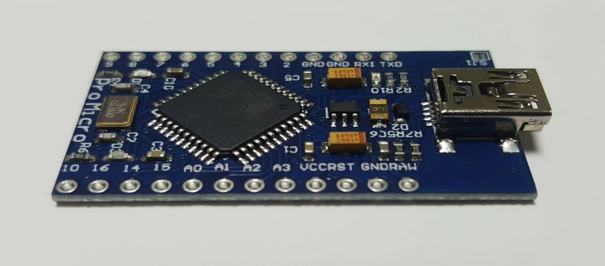

**Circuit Description:**

The IR sensor detects the presence of a user's hand near the faucet.

The microcontroller processes the signal and activates the solenoid valve to allow water flow.

The microcontroller sets a timer for water flow duration to conserve water.

**3. Smart Toilet Flushing System**

**Components:**

Ultrasonic Sensor:

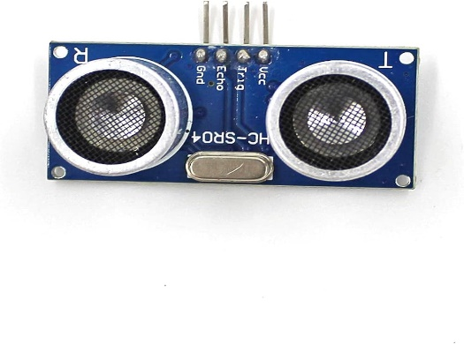

Solenoid Valve

Microcontroller

**Circuit Description:**

The ultrasonic sensor measures the distance to detect if the toilet is occupied.

If occupied, the microcontroller prevents flushing until the toilet is vacant.

When vacant, the microcontroller activates the solenoid valve to flush the toilet.

**4. Hand Sanitizer Dispenser**

**Components:**

IR Sensor (for hand detection)

Motorized Dispenser

Microcontroller

**Circuit Description:**

The IR sensor detects the presence of a user's hand.

The microcontroller triggers the motorized dispenser to dispense sanitizer.

**5. Air Quality and Temperature Sensor**

**Components:**

Air Quality Sensor (e.g., CO2, VOC)

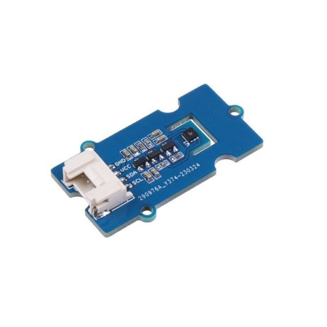

Temperature Sensor

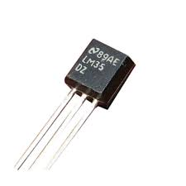

Microcontroller

**Circuit Description:**

The sensors monitor air quality and temperature.

The microcontroller processes the data for analysis or displays it on a screen for users.

**6. Display and User Interface**

**Components:**

LCD Display

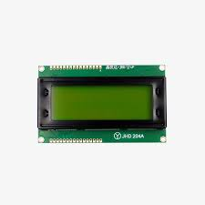

Microcontroller

Push Buttons (for manual overrides or settings)

**Circuit Description:**

The microcontroller communicates with the LCD display to provide feedback to users.

Push buttons allow manual control or adjustment of settings.

**7. Communication Module (Optional)**

**Components:**

Wi-Fi or Bluetooth Module

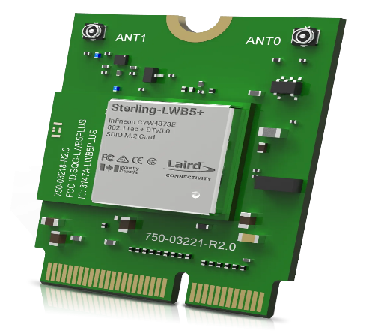

Microcontroller

**Circuit Description:**

The communication module allows the restroom system to connect to a central control or be accessed remotely for monitoring and control.

## THE SIMPLE CIRCUIT DIAGRAM FOR SMART RESTROOM SYSTEM

The following is a simple circuit diagram for a smart restroom system using a microcontroller:

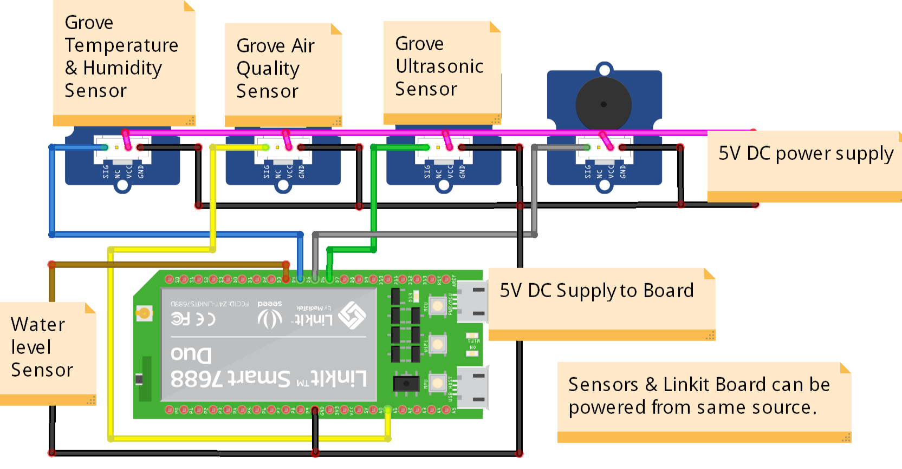

This a simple and basic circuit diagram of the smart restroom using iot.